**Group Number:** 3

**Group Members:**

|  |  |  |
| --- | --- | --- |
| Name - EID | % Contribution to UI design | % Contribution to paper |
| Ben Nguyen - bpn252 |  |  |
| Chris Cale – clc3648 |  |  |
| Nicholas Cobb – ndc497 |  |  |

**ApplicationName:** BuildABudget

**Application Description:**

This application assists users in building and maintaining a budget so that they can meet their financial goals. Users will stipulate the sources of their regular monthly income and expenses, as well as, their financial goals, such as saving up for a dream vacation, to enable them to generate a monthly budget plan. The application will utilize easy to understand visualizations, such as check lists and bar graphs, to inform the user of their progress toward meeting their goals and budgets, as well as, allowing them to test the impact that one-time transactions will cause. Users will be able to generate itemized transaction reports and export their financial data. Lastly the application will employ notifications to encourage and keep the user on track to meet their planned budgets and financial goals.

**Mockups:**

Login Screen

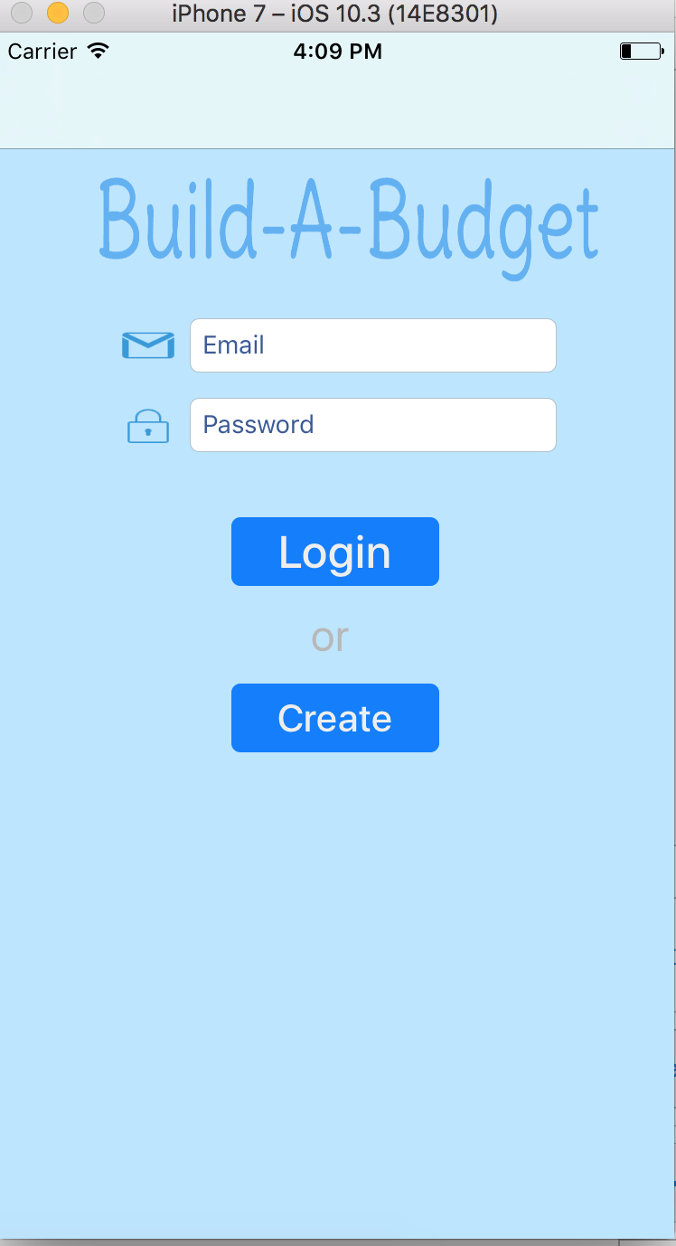

This screen is where the user can login or create an account. If the user wishes to login to his current account, he must enter both his email address (which serves as his username) and his password. The user can also create a new account to use the app. Clicking on the 'Create' button will take the user to the create account screen.

Settings Screen

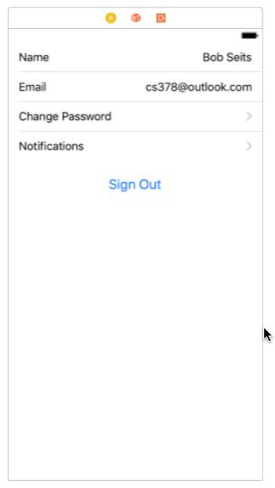

A screen in which the user changes settings. The things that can be changed are name, login email, password and notifications. Additionally, the user can sign out.

Create Account Screen

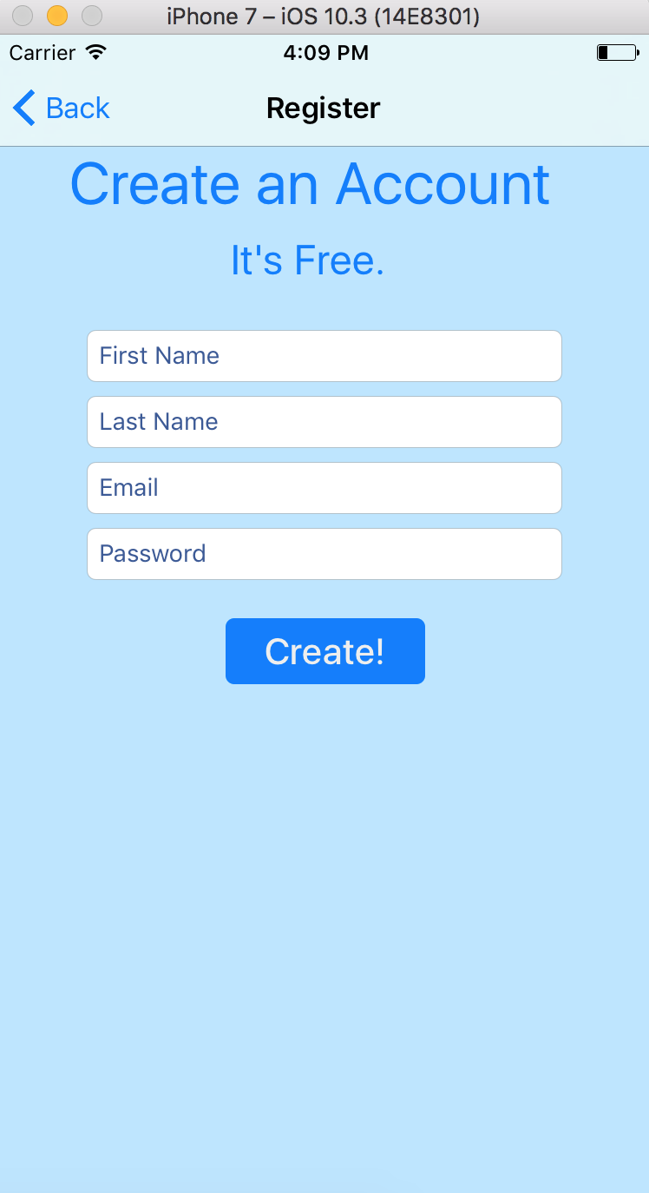  
  
This is where a new user can create a new account so he can start using the app. The user must provide both his first and last name. His email address will be used as his username to login in. Of course, a password is required as well. The 'Create!' button will create the account, assuming that an account with that email address hasn't already been taken.

Launch Screen:

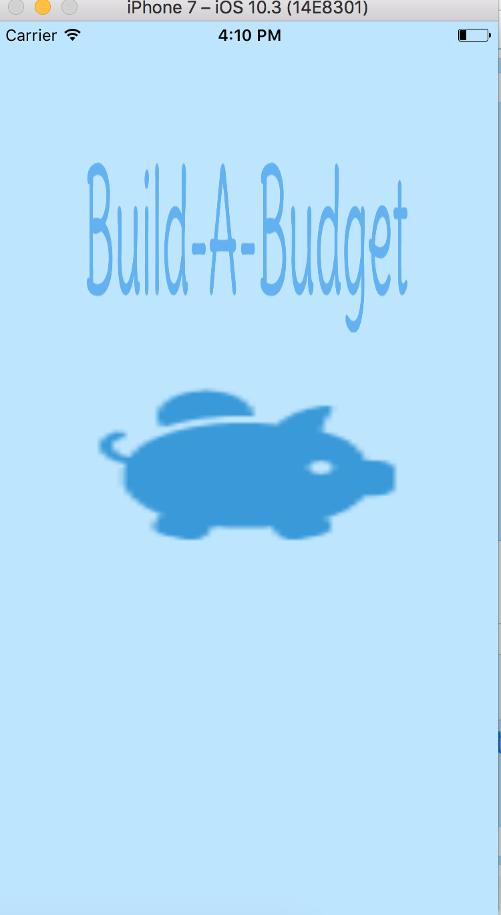

The launch screen is where the user will first see when the user first launches the app. There is nothing for the user to do besides to wait for the app to take him to the logins screen.

Over View:

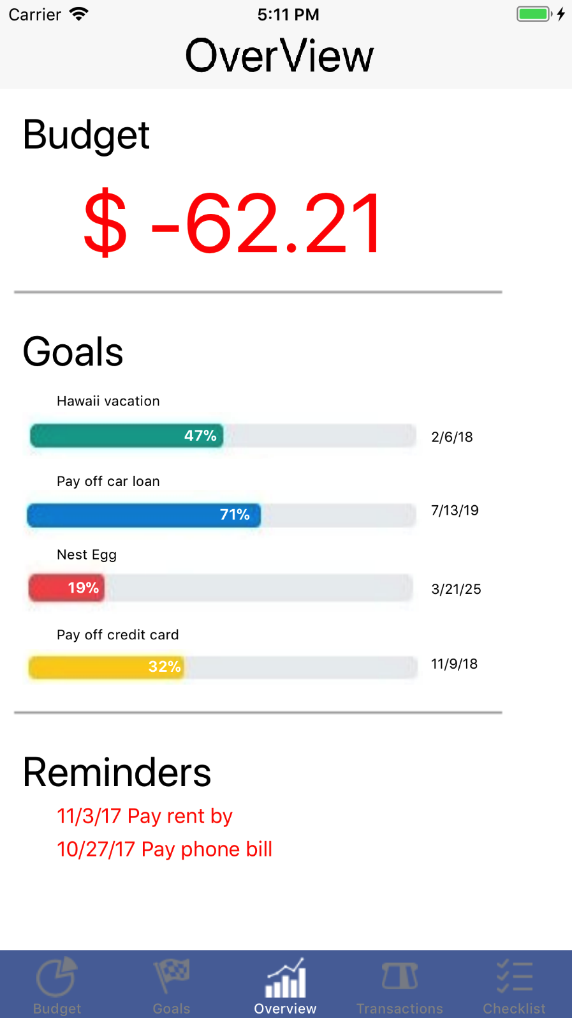

The overview screen is the default screen that the user lands on after logging in. The overview tab view controller functions as an aggregation of status highlights of the most important information contained in the app. The user will first see the prominent heading Budget which provides their current financial status in relation to their budget. The figure will be either a negative red number or a positive black number. The red color serves to reinforce that this is a negative amount so that it cannot be misinterpreted during a glance.

Goals:

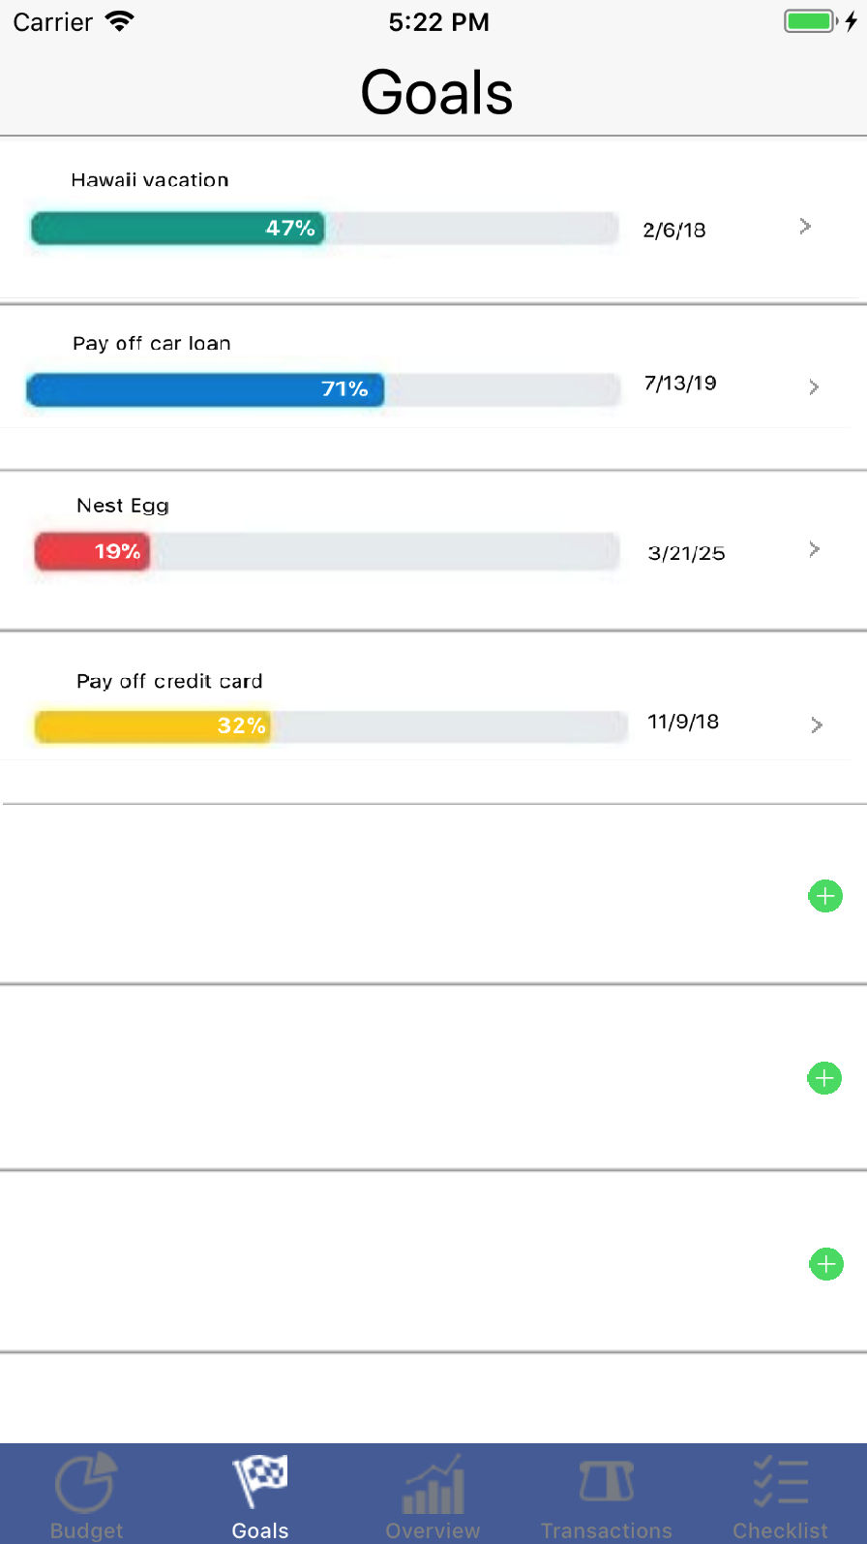

The Goals tab view controller seeks to list all the user’s active financial goals in a list ordered by creation date to make goals easier to search, since it is assumed that user remembers roughly if a certain goal is older than another one. Furthermore, the assumption that older goals will be have had more time to mature will mean that typically the user will see more goals that are closer to completion as soon as they open this tab thereby creating a positive visual reinforcement that encourages users to keep pursing their goals because the first few goals they see will likely be closer to completion.

Edit Goals:

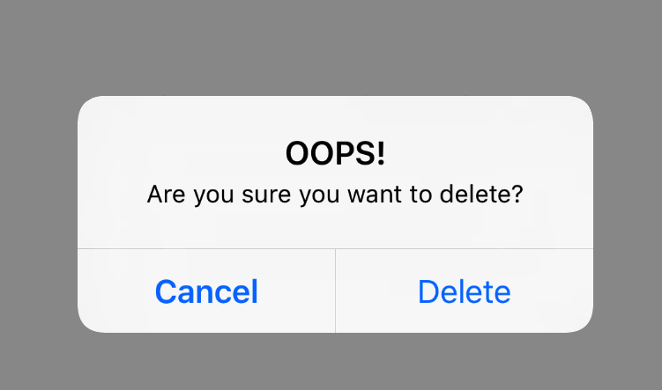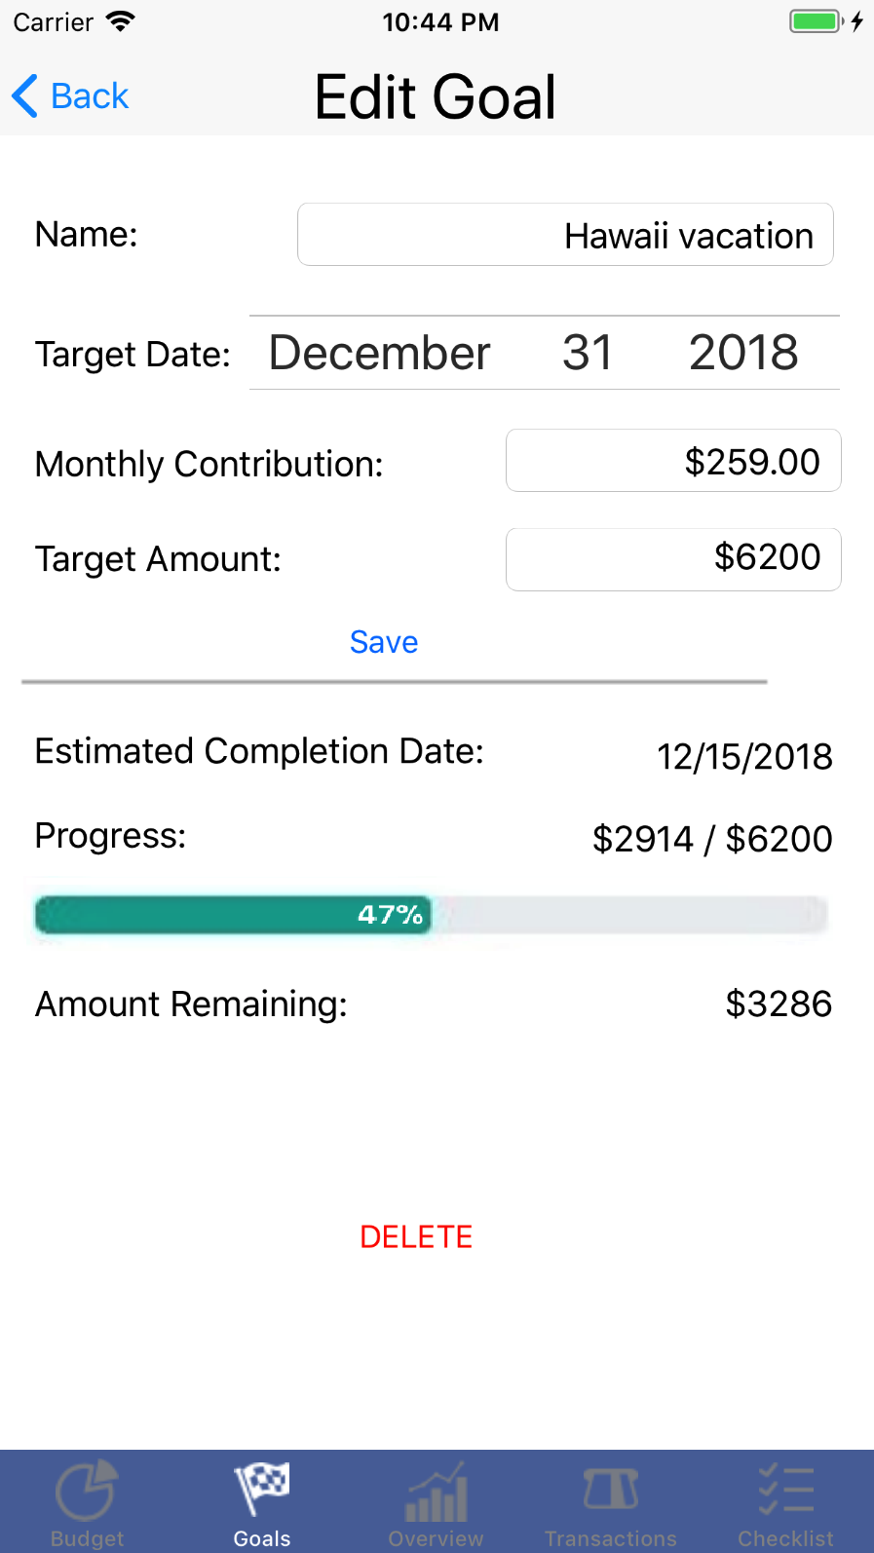

The Edit Goals view controller is only accessible by clicking on the edit arrow adjacent to the Goal in the Goals view controller the user wants to edit. This is done to avoid unintended clicks and to maintain an easy to remember work flow for the user. This view controller provides two sections that are visually separated by a bar to distinguish the editable information from the un-editable data that this goal has already generated.

Monthly Budget:

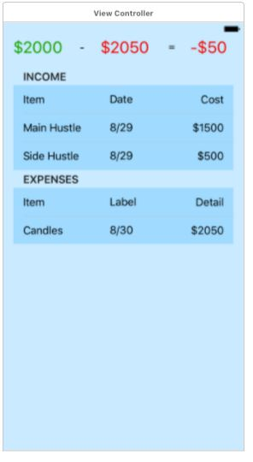

Monthly Income and Expenses: A screen in which the user can view, add and remove individual sources of income and expense. This screen is useful for the user to keep track of how much they are spending and what they are spending money on.

Reminders:

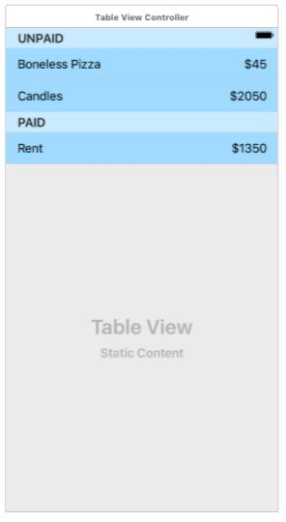

A screen in which the user can view, add and remove reminders for monthly bills/recurring expenses that need to be paid. These are separated by whether they have been paid for the month yet or not.

Tutorials